Fighter Cockpit Adaption to Online Situation Awareness Measurement
Simon Schwerd¹ and Axel Schulte¹
¹ Institute of Flight Systems, Universität der Bundeswehr München, 85577 Neubiberg
{simon.schwerd, axel.schulte}@unibw.de

INTRODUCTION
Fighter pilots face a broad task spectrum in the cockpit. Their tasks are considerably more challenging than those of civil pilots due to additional mission tasks, which include control of sensors, weapons, and other systems, under consideration of constraints and uncertainties. In addition, the pilots coordinate with manned and, as envisioned in fighter development programs (e.g., FCAS), unmanned platforms. This adds coordination with manned-unmanned teams to the pilots’ responsibilities (Lindner et al., 2022). In this multitasking environment, efficient management of attention is crucial to pilot performance (Olivier Lefrancois et al., 2016). Attention-related problems in human-automation interaction are well known and often described as a possible cause of aviation accidents (Jones & Endsley, 1996; Kelly & Efthymiou, 2019; Shorrock, 2007). There are different problems described in literature, such as attentional tunneling (Wickens, 2005), inattentional blindness or deafness (Dehais et al., 2019), vigilance performance decrement (Thomson et al., 2015) or complacency (Parasuraman & Manzey, 2010). The consequence of all these phenomena is a loss of situation awareness (SA) in specific situational aspects when the pilot fails to attend relevant information in the cockpit (Jones & Endsley, 1996). Effective training in monitoring and automation operation is crucial to improve pilot attention management, but nevertheless, the interaction between pilots and cockpit remains ‘hierarchical’ in the sense, that the cockpit cannot be aware of the pilot’s errors. In this context, the idea of developing user-aware systems has been proposed to enable error-reducing adaption of a workplace (Brand & Schulte, 2018; Fortmann & Mengeringhausen, 2014; Peysakhovich et al., 2018).

In this contribution, we focus on the adaption of a fighter cockpit to an online estimation of the pilot’s cognitive state, more specifically their attention allocation and situation awareness. Thus, our design goal is a system that reduces the number of situations where a pilot misses critical information while trying to avoid nuisance notifications (Schwerd & Schulte, 2021b). To achieve automatic online estimation of SA, we developed an eye-tracking analysis approach where, for every fixation on the cockpit display, an application provides the attended object and a parametric description of their relevant content (e.g., not only “altimeter”, but also the altitude; not only ‘hostile aircraft’, but also its heading, speed, and distance). This information is used to populate nodes in a dynamic semantic network that represents the relevant situational features and relationship between information, e.g., when the pilot is aware of the position of two objects, he can also infer a distance between them. Each network node contains a measure of deviation between the assumed pilot’s awareness and the actual state of this situational feature. Therefore, the system can estimate the SA in specific situational features. In prior studies, we validated this approach in cockpit simulator studies and showed correlations of our SA measure with performance and subjective SA ratings (Schwerd & Schulte, 2020, 2021a). We used this SA model in a subsequent experiment to trigger cockpit adaptions and alerts to guide the pilot’s attention towards critical system information when the deviation in relevant situational features grew above a certain threshold. With that, we could improve pilot performance in those situations where a change of task-relevant system state could not have been predicted by the participants (Schwerd & Schulte, 2021c).

While our approach worked reasonably well in our laboratory trials, transfer to real-world military application is not trivial. Apart from challenges like eye-tracking measurement in real cockpits, the adaptions must be useful in the task context and should provide benefits to the pilot. Thus, our central question is: which cockpit information is relevant in which task situation? To answer this question, we conducted a goal-directed task analysis (GDTA) with eight fight pilots. Based on this task analysis, we identified use-cases, which were implemented in our cockpit simulator. Then, we evaluated these use-cases with three fighter pilots of the German Air Force.

METHOD

Step 1: Task Analysis to identify Use-cases

Method
The GDTA was proposed by (Endsley & Jones, 2012) and can be used to structure a task environment by its goals, decisions to meet these goals, and information requirements to make these decisions. It is especially suitable for our research question because the task analysis associates information with its context. For the interview, we prepared different mission scenario briefings (e.g., Air Interdiction Mission) to structure the discussion. On basis of these scenarios, we went through different mission phases to identify relevant operational decisions. When we identified a decision, we asked about all relevant information that is associated with this information.

Procedure & Participants
We interviewed eight fighter pilots from the German Air force (all male, mean age 36.2y). Only one pilot was interviewed per session which lasted about two hours for each pilot. In our setting, pilots could only talk about non-classified information. After the interviews, we organized goals, decisions, and information into a tree-like structure.

Results
The resulting GDTA is structured by five main goals, which are displayed in Figure 1. For example, the first goal is to operate the aircraft under consideration of the mission plan. Every main goal consists of several subgoals, also illustrated for goal 1.0 in Figure 1.

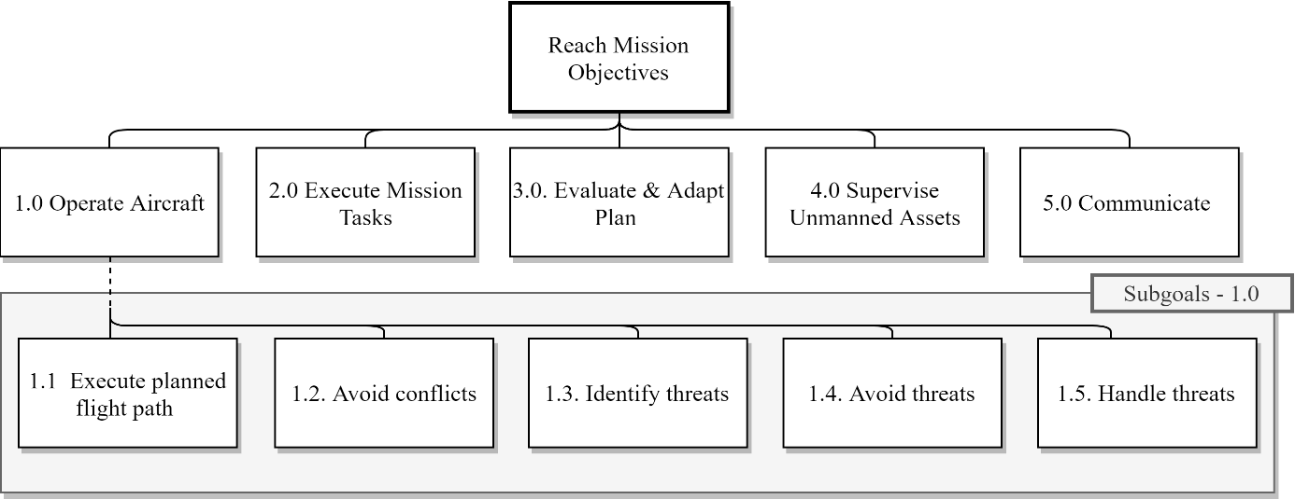
Figure 1: Top-level extract from analysis
Decisions are associated in the lower levels of the structure and always associated with a subgoal. Figure 2 shows three examples for relevant decisions, that must be frequently done in the cockpit. For example, the subgoal ‘assess planned flight altitude’ is associated with the decision if a change to the UAV altitude is necessary because there is a more secure route available. To make this decision, the pilot must collect information in the cockpit about the current position and types of threats, the current UAV altitude, and its planned UAV altitude.
Given the many decisions and information requirements from the analysis, we selected suitable use-cases suitable to evaluate them in the cockpit simulator.

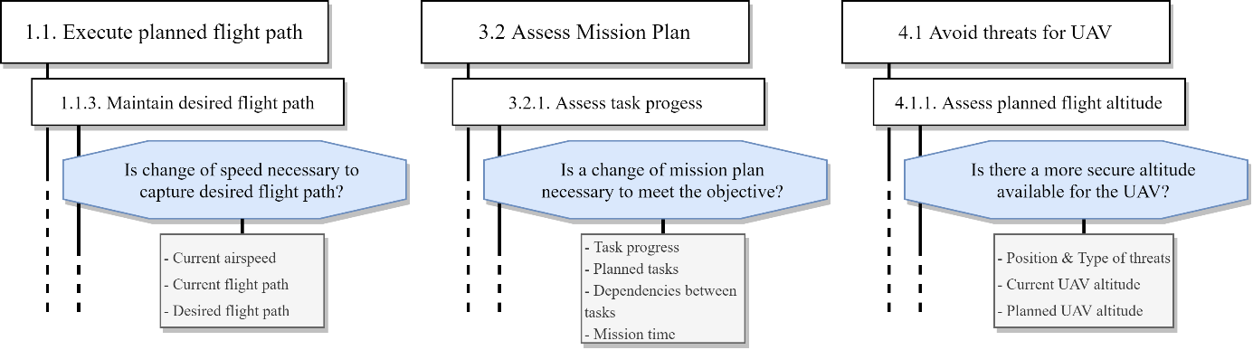
Figure 2: Example decisions from different goals

Step 2: Prototype Evaluation

Method
The second step of this study was the implementation and evaluation of a cockpit adaption in a representative task setting. For this, we implemented 12 different adaption use cases in our cockpit simulator (see Figure 3). Cockpit adaptions were either a computer-generated text message or an indication on the tactical map.
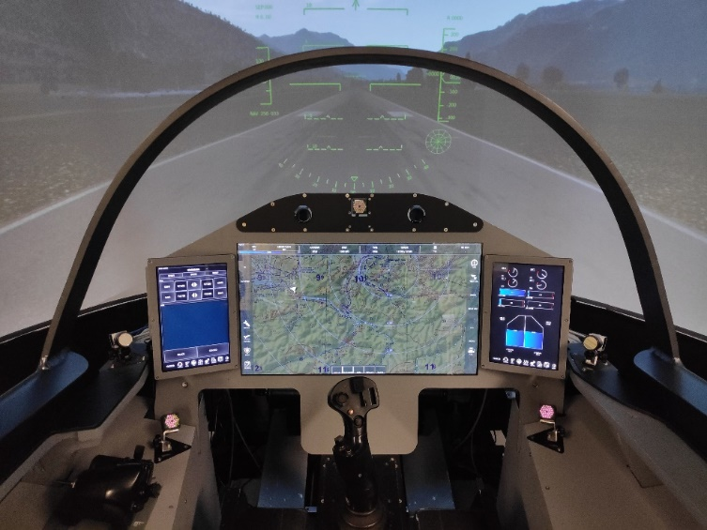
Figure 3: Cockpit simulator with integrated eye-tracking
Procedure & Participants
We invited three fighter pilots to evaluate our system. Mean age was 36y with mean flight hours on a fighter jet of 600h. After a training of 2 hours, we fully explained the basic principle of the cockpit adaption and introduced all use cases. Then, we evaluated the implemented assistance system in three scenarios. Each scenario emphasized different mission types and pilot tasks (Reconnaissance, UAV Control and MUM-T Air Interdiction). After each scenario, the participants were asked to fill out a subjective usability rating about every specific assistance use case they encountered. After all scenarios, we replayed a recording of each trial and interviewed the pilots about specific situations to gain further insight into their rating and possible improvements.

Results
The subjective rating, debriefings and preliminary analysis of the logging data showed the following:
- The SA-based adaption was accepted well by the pilots and subjective rating was positive. The use-cases were considered to be useful in a real-world task setting. Especially indications in the tactical map were evaluated as very helpful. In addition, pilots asked for phase-of-flight specific use cases (e.g., take-off, landing).
- In a few situations, pilots did not monitor a certain cockpit display because they relied on the auditive text messages telling them relevant information. In other cases, pilots criticized when text messages contained a lot of information.
- Pilots ignored system indications as soon as the workload was high. Because of this, they often could not recall an encountered use-case in some trials.
- Pilots disliked to system indications that merely told them information they should know from a perspective of SA. In their opinion, the SA-based indication should only appear when there is action required.

Discussion
Our experiment showed that we successfully implemented use-cases, that are useful in a real-world fighter jet cockpit. However, one flaw of our approach is, that in situations where the pilot focuses on a single demanding task while ignoring other information, our system tends to trigger more indications since SA in task-irrelevant information suffers from the attentional focus on a single task. But these indications are often ignored due to high workload or might even add more workload. This problem could be solved by two approaches: Either delaying indications until the pilot is finished with his task depending on a measurement of activity (Honecker & Schulte, 2017) or, in critical cases, interrupt the pilot with more drastic cockpit adaptions such as cognitive counter measures (Saint-Lot et al., 2020). We are planning to evaluate these approaches in our future studies.

References
Brand, Y., & Schulte, A. (2018). Design and Evaluation of a Workload-Adaptive Associate System for Cockpit Crews. In D. Harris (Ed.), Engineering Psychology and Cognitive Ergonomics (pp. 3–18). Springer International Publishing.
Dehais, F [Frederic.], Roy, R. N., & Scannella, S. (2019). Inattentional deafness to auditory alarms: Inter-individual differences, electrophysiological signature and single trial classification. Behavioural Brain Research, 360, 51–59. https://doi.org/10.1016/j.bbr.2018.11.045
Endsley, M. R., & Jones, D. G. (2012). Designing for situation awareness: An approach to user-centered design / Mica R. Endsley and Debra G. Jones (2nd ed.). CRC Press.
Fortmann, F., & Mengeringhausen, T. (2014). Development and Evaluation of an Assistant System to Aid Monitoring Behavior during Multi-UAV Supervisory Control. In C. Stary (Ed.), Proceedings of the 2014 European Conference on Cognitive Ergonomics - ECCE '14 (pp. 1–8). ACM Press. https://doi.org/10.1145/2637248.2637257
Honecker, F., & Schulte, A. (2017). Automated Online Determination of Pilot Activity Under Uncertainty by Using Evidential Reasoning. In D. Harris (Ed.), Lecture Notes in Computer Science. Engineering Psychology and Cognitive Ergonomics: Cognition and Design (Vol. 10276, pp. 231–250). Springer International Publishing. https://doi.org/10.1007/978-3-319-58475-1_18
Jones, D. G., & Endsley, M. R. (1996). Sources of situation awareness errors in aviation. Aviation, Space, and Environmental Medicine, 67(6), 507–512.
Kelly, D., & Efthymiou, M. (2019). An analysis of human factors in fifty controlled flight into terrain aviation accidents from 2007 to 2017. Journal of Safety Research, 69, 155–165. https://doi.org/10.1016/j.jsr.2019.03.009
Lindner, S., Mund, D., & Schulte, A. (2022). How Human-Autonomy Teams change the Role of future Fighter Pilots: An Experimental Assessment. In AIAA SCITECH Forum. https://doi.org/10.2514/6.2022-2551
Olivier Lefrancois, Nadine Matton, Yves Gourinat, Vsevolod Peysakhovich, & Mickaël Causse (2016). The role of Pilots’ monitoring strategies in flight performance. In European Association for Aviation Psychology Conference EAAP32. https://oatao.univ-toulouse.fr/16173/
Parasuraman, R., & Manzey, D. H. (2010). Complacency and bias in human use of automation: An attentional integration. Human Factors, 52(3), 381–410. https://doi.org/10.1177/0018720810376055
Peysakhovich, V., Lefrançois, O., Dehais, F [Frédéric], & Causse, M. (2018). The Neuroergonomics of Aircraft Cockpits: The Four Stages of Eye-Tracking Integration to Enhance Flight Safety. Safety, 4(1), 8. https://doi.org/10.3390/safety4010008
Saint-Lot, J., Imbert, J.‑P., & Dehais, F [Frédéric] (2020). Red Alert: A Cognitive Countermeasure to Mitigate Attentional Tunneling. In R. Bernhaupt, F. '. Mueller, D. Verweij, J. Andres, J. McGrenere, A. Cockburn, I. Avellino, A. Goguey, P. Bjørn, S. Zhao, B. P. Samson, & R. Kocielnik (Eds.), Proceedings of the 2020 CHI Conference on Human Factors in Computing Systems (pp. 1–6). ACM. https://doi.org/10.1145/3313831.3376709
Schwerd, S., & Schulte, A. (2020). Experimental Validation of an Eye-Tracking-Based Computational Method for Continuous Situation Awareness Assessment in an Aircraft Cockpit. In D. Harris & W.-C. Li (Eds.), Lecture Notes in Computer Science. Engineering Psychology and Cognitive Ergonomics. Cognition and Design (Vol. 12187, pp. 412–425). Springer International Publishing. https://doi.org/10.1007/978-3-030-49183-3_32
Schwerd, S., & Schulte, A. (2021a). Measuring the Deviation between Ground Truth and Operator Awareness in a UAV Management Scenario: An Eye-Tracking Approach. In AIAA Scitech 2021 Forum. American Institute of Aeronautics and Astronautics. https://doi.org/10.2514/6.2021-1579
Schwerd, S., & Schulte, A. (2021b). Operator State Estimation to Enable Adaptive Assistance in Manned-Unmanned-Teaming. Cognitive Systems Research, 67, 73–83. https://doi.org/10.1016/j.cogsys.2021.01.002
Schwerd, S., & Schulte, A. (2021c). Situation Awareness Adaptive Alerting in an Aircraft Cockpit: A Simulator Study. Preprint. Advance online publication. https://doi.org/10.31224/osf.io/9gmnv
Shorrock, S. T. (2007). Errors of perception in air traffic control. Safety Science, 45(8), 890–904. https://doi.org/10.1016/j.ssci.2006.08.018
Thomson, D. R., Besner, D., & Smilek, D. (2015). A resource-control account of sustained attention: Evidence from mind-wandering and vigilance paradigms. Perspectives on Psychological Science : A Journal of the Association for Psychological Science, 10(1), 82–96. https://doi.org/10.1177/1745691614556681
Wickens, C. D. (2005). Attentional Tunneling and Task Management. International Symposium on Aviation Psychology.

