Machine Learning for Drone Conflict Prediction: Simulation Results
Brian Hilburn, Ph.D.
Center for Human Performance Research (CHPR BV)
Voorburg, the Netherlands
brian@chpr.nl
tel +31 6 1227 69 79

- Introduction
The possible introduction of drone traffic into urban airspace has many in the air traffic management (ATM) community wondering how to accommodate such a fundamentally new type of aircraft, whose potential numbers and unpredictability might overwhelm current human-based methods for managing air traffic. One possible solution lies in the use of Machine Learning (ML) techniques for predicting (and possibly resolving) drone conflicts in high density airspace.
The aim of this research was not to develop an optimised ML model per se, but to experimentally explore via low-fidelity offline simulations the potential benefits of ML for drone conflict prediction, specifically: how well can a simple ML model predict on the basis of instantaneous traffic pattern snapshot, whether that pattern will result in an eventual airspace conflict (defined as entry into a stationary prohibited zone)? Secondly, how is model performance impacted by such parameters as traffic level, traffic predictability, and ‘look-ahead’ time of the model?

Methods
  - Airspace and traffic assumptions
This effort started from several assumptions. First was the focus on the ‘edge case,’ or worst-case scenario. If ML were able to predict conflicts under the most challenging possible assumptions, real world results would likely be better. For reasons of this analysis, traffic assumptions therefore included the following:
- Urban Air Mobility (UAM) scenario —envisions short flight times, and frequent trajectory changes;
- High traffic density—this is implicit in predicted future urban drone scenarios, but we intended to push the limits of traffic level;
- Lack of intent information—no flight plan information (regarding filed destination, speed, altitude, heading changes, etc) would be available. Instead, only the minimal (instantaneous) state information would be provided;
- Random drone movements—ML conflict prediction would be trivial if all drone movements were completely predictable. In reality, VLL drone operations will have a fair amount of structure and determinism. However, we intentionally introduced a high level of randomness in drone movements, again to test the worst case scenario for ML;
- Prohibited airspace— was represented as static no-go regions (e.g, around security sensitive areas). This analysis included a single, static “no drone zone,” and conflicts were defined as penetrations of this zone.

  - Methodological assumptions
This effort set out to test ML conflict prediction using the most challenged methods. Specifically, this meant that whatever ML model we used, must have no ability to look either forward or backward in time, nor make use of any other information beyond the simple instantaneous state of each drone. For research purposes, the conflict prediction problem was simplified to one of pattern recognition. We used a supervised learning approach, and in particular a fairly limited architecture: the standard deep learning (i.e., multi hidden layer) artificial neural net. Whereas enhancements to the neural net approach (including RNN, CNN, and LSTM enhancements) would be expected to show better time series processing and thus better classification performance, we set out to use a simpler neural net architecture, to establish baseline worst case model performance. Moreover, we set out to train different models (36 in all) so that model performance could be compared experimentally, to assess the impact of traffic level, traffic randomness, and look-ahead window range, on ML conflict prediction performance.

Drone test scenarios and traffic samples

The urban drone environment was represented by a 20 x 20 grid of 400 total cells. Each cell was either occupied or empty. Developmental testing established the number and size of restricted areas, so as to produce a reasonable number of Prohibited Zone (PZ) incursions. It was decided to use a single, stationary PZ, as shown in Figure 1. One simplifying assumption was that altitude was disregarded, and drone movements were only considered in two dimensions (the PZ was assumed to be from the surface upward). Second, there were no speed differences between drones. Finally, conflicts were only defined as airspace incursions into the PZ, not as losses of separation between drones (drones were assumed to maintain vertical separation).

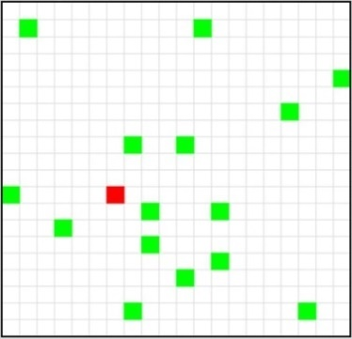
Figure 1. Snapshot, traffic sample of 16 birthed drones (note PZ in red).

Traffic samples were built from three different kinds of drone routes, as shown in Figure 2. Notice that drones could only fly on cardinal headings (North, South, East, or West). Through-routes transited the sector without any heading change. TCP-routes (i.e. Trajectory Change Point routes) added probabilistic heading changes to through-routes. After a random interval of 3-6 steps, TCP-route drones would either continue straight ahead, or make a 90° left/right heading change. The random TCP function was nominally weighted to 50% no heading change (i.e. continue straight ahead), 25% left turn, and 25% right turn. Finally, the ten possible Bus-routes (5 routes, flown in either direction) were pre-defined TCP trajectories. Bus-route drones all entered the sector after sample start time, except for bus-routes 9 and 10 (which flew a square pattern in the centre of the sector, and were birthed already on their route).
As discussed later, analysis compared “random” and “structured” route conditions, as an experimental manipulation. The random condition used TCP-routes exclusively. The structured condition used a random combination of through-routes and bus-routes.
Each traffic sample consisted of 40 time steps. First appearance of each drone was randomly timed to occur between steps 1 and 15. Each drone maintained current heading by advancing one cell per time step (no hovering). This meant that a through-route drone would transit the sector in 20 steps. Each traffic sample also consisted of 4, 8, or 16 birthed drones (this was also an experimental manipulation, as described later). Because birth time was randomized, the actual number of instantaneous in-sector drones could vary.
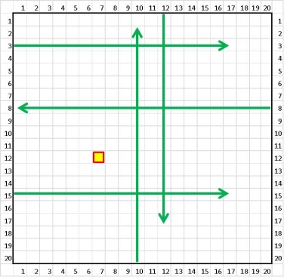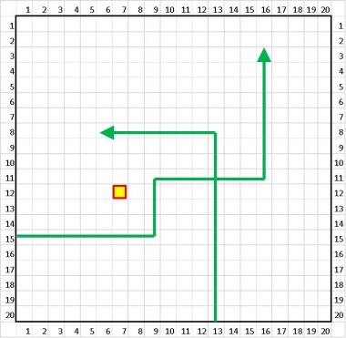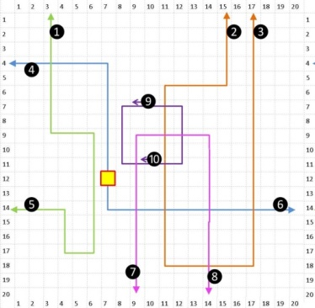
Figure 2. Through-routes (left), TCP-routes (centre) and bus-routes (right).

Analysis used a 3x2x2 experimental design and varied the following factors:
- Aircraft count (4 vs 8 vs 16)— the total number of birthed aircraft;
- Look-ahead time (Low vs High)— Snapshot time, in number of steps before conflict;
- Traffic structure (Low vs High)— Randomised vs semi-structured traffic flows.

ANN design

Neural network modelling was done in NeuralDesigner v2.9, a machine learning toolbox for predictive analytics and data mining, built on the Open NN library. Modelling used a 400.3.1 architecture (i.e., 400 input nodes, a single hidden layer of 3 nodes, and a single binary output node), with standard feedforward and back propagation mechanisms, and a logistic activation function. Each of the 400 total cells was represented as an input node to the network. Each input node was simply coded on the basis of occupation, i.e. a given cell was either occupied (1) or empty (0). The output node of the ANN was simply whether the traffic pattern evolved into an eventual conflict (0/1). Maximum training iterations with each batch was set to 1000.
  - Procedures
The overall flow of the traffic generation, pre-processing, and ANN modelling process is shown in Figure 3. Using a traffic generation tool, preliminary batches of 5000 traffic samples each were created. Separate batches were created for each combination of aircraft count and structure level. For each batch, samples were then automatically processed to identify conflict versus non-conflict outcomes, extract multiple look-ahead snapshots (for 1-6 steps) from conflict samples, and extract matching yoked snapshots from non-conflict samples. Target outputs were then labelled, and sample groups were fused into a final batch file. This batch file was then randomly split 60/40 into training and testing sub batch files. After training each of the 36 networks with its appropriate training sub batch file, each network was tested on its ability to classify the corresponding test sub batch file. The following section presents the results of this testing.
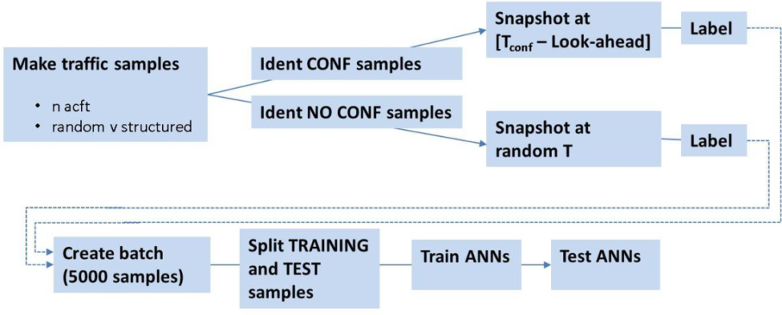
Figure 3. Overview, traffic creation and model testing procedure.
- Results

  - Binary classification accuracy
The simplest performance measure is classification accuracy. That is, what percentage of samples was correctly classified as either conflict or no conflict? The ANN models each had a simple binary output: either an eventual conflict was predicted, or was not. This is a classic example of a binary classification task, which is characterized by two ‘states of the world’ and two possible predicted states. A binary classification table, as shown in Figure 4, allows us to identify four outcomes: True Positive (TP), True Negative (TN), False Positive (FP), and False Negative (FN). In signal detection parlance, these outcomes are referred to, respectively, as: Hits, Correct Rejections, False Alarms, and Misses.

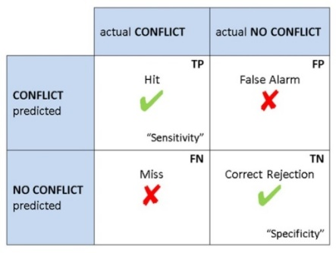
Figure 4. Binary classification outcomes.

These four classification outcomes allow us to define the following rates:

- Accuracy— the rate of proper classification, defined as: ACC = [TP+TN] / [TP+FN+TN+FP]
- Error Rate = 1-ACC = [FN+FP] / [TP+FN+TN+FP]
- True Positive Rate (aka sensitivity) = TP / [TP+FN]
- True Negative Rate (aka specificity) = TN / [TN+FP]

For structured traffic, there seemed to be a ceiling effect on classification performance. Classification accuracy approached optimum (falling no lower than .948) regardless of traffic or look-ahead time. This means that, with structured traffic, the ANN model was able to predict almost perfectly which traffic samples would result in conflict. This was not surprising. As discussed earlier, under structured traffic the majority (84%) of drones would be predictable by the second step after sector entry. By step 3, the only uncertainty would be whether the other 16% were on through-routes or bus-routes.

Random traffic, however, showed some variations in model performance. Classification performance with random traffic was still impressively high, ranging from .72 to .98, and generally well above chance levels (a Youdens Index value of 0.5, as shown in Table 2, would indicate a guessing level). However, under random traffic (Table 3) we began to see ML performance declines with both look-ahead time and traffic count (classification performance worsened with each), and a trend toward a three-way interaction between traffic, structure, and look-ahead.

Figure 5 shows the effect of both look-ahead and aircraft count, on overall classification accuracy. Data are somewhat collapsed in this view. Look-ahead (1-6) is binary split into Low (1-3) and High (4-6). Aircraft count includes only the extremes of 4 and 16. Besides a main effect of both look-ahead (longer look-ahead worsened performance) and aircraft count (higher count worsened performance), there is a slight trend toward a look-ahead x aircraft count interaction. Notice the interaction trend, whereby longer look-ahead had a greater cost under high traffic.

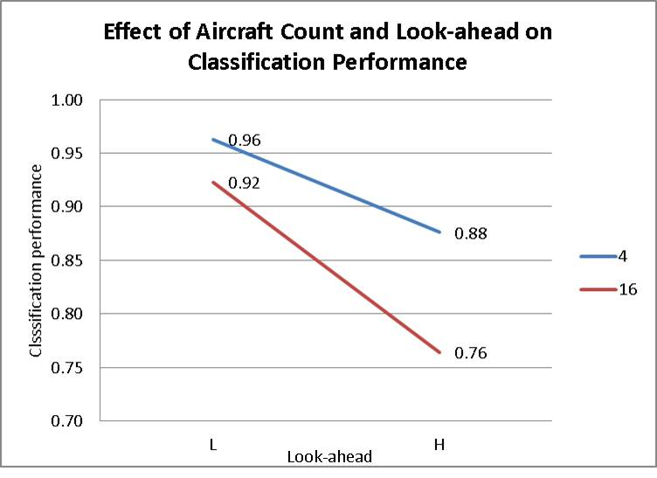
Figure 5. Effect of aircraft count and look-ahead on overall classification performance, random traffic only.

3.2 Classification sensitivity and specificity

For a finer-grained view, see the three panels of Figure 6. These present classification performance under random traffic, for low, medium, and high aircraft count (from left to right panel). Each panel also shows the impact of look-ahead, from 1-6 steps. Notice that the pattern of Sensitivity (the TPR) and Specificity (TNR) vary by aircraft count. Basically, ML overall performance worsened with look-ahead time, but the underlying patterns (TPR, TNR) differed by aircraft count. For low traffic, Sensitivity fell disproportionately (i.e., the model tended toward FN rather than FP). For high traffic, Specificity fell (the system tended toward FP rather than FN). At the highest level, this interaction trend suggests that our ANN model tended to disproportionately false positive under the most demanding traffic samples.

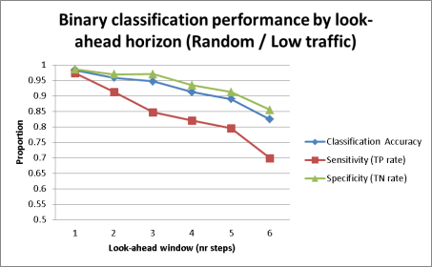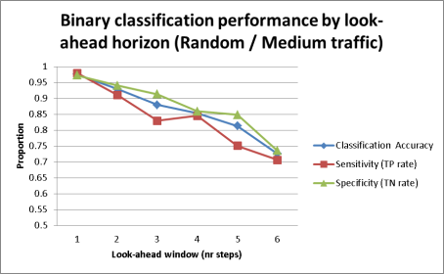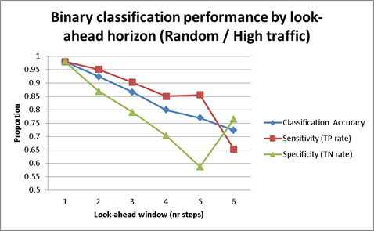
Figure 6. Classification performance, sensitivity, and specificity, for random traffic.

  - The extreme scenario
To test one final, and even more challenging case, we generated traffic and trained / tested an ANN model, using random traffic, 24 aircraft, and a look-ahead of 6 (see Figure 7).

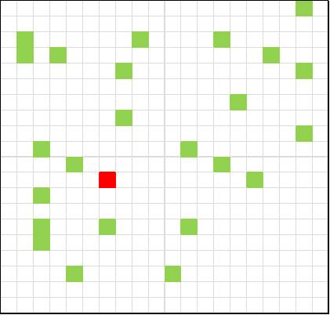
Figure 7: The extreme scenario: 24 drones, random traffic, and a six-step look-ahead.

Classification accuracy remained surprisingly high in this condition (in fact, slightly above the 16 drone sample). Also, this extreme scenario extended the trend toward Specificity decrement seen in the three panels of Figure 6.

Table 1. Results summary, binary classification performance, extreme scenario.
Classification accuracy | 0.739
Error rate | 0.261
Sensitivity (TP) | 0.705
Specificity (TN) | 0.758
False Positive Rate (FP) | 0.242
False Negative Rate (FN) | 0.295

  - Summary of results
In terms of conflict prediction performance, results from our ML model can be summarized as follows:
- With structured traffic, overall model performance was nearly perfect;
- With structured traffic, no effect of traffic count nor look-ahead could be found;
- For random traffic, the model still performed quite well;
- For random traffic, traffic count and (more so) look-ahead had a clear impact on overall classification accuracy;
- This look-ahead effect on accuracy revealed subtle differences in other parameters. For low traffic, Sensitivity (TP rate) declined more than did Specificity (TN rate). For high traffic, this was reversed, In other words, longer look-ahead worsened overall classification performance, but low traffic was biased toward false negatives, and high traffic was biased toward false positives;
- Even under the most challenging conditions (random, high traffic, long look-ahead), ML classification accuracy was still fairly high (76.5%);
- Even with random traffic, classification performance was generally well above guessing level, far better than chance;
- The ANN approach continued to show robust classification performance, even when presented an extreme case of 24 drones, random traffic, and long look-ahead.

